# Exercise: Introduction to HTML and CSS

Problems for exercises and homework for the ["HTML and CSS" course @ SoftUni](https://softuni.bg/courses/html-and-css). Submit your solutions in the SoftUni Judge system at <https://judge.softuni.org/Contests/3330/Introduction-to-HTML-and-CSS>.

## Install and Configure Visual Studio Code for HTML

Install **VS Code** by using the guide in the resources of that lab.

1. **Start** with Visual Studio Code.
2. Create and select the **working folder** in which we will create our first HTML page.

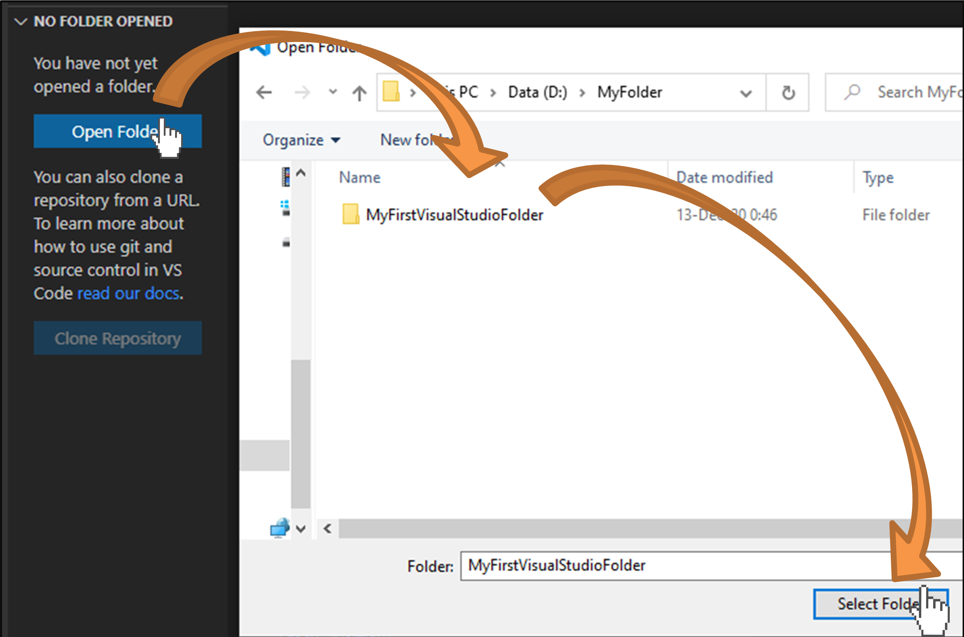

1. Create a new **HTML file**:

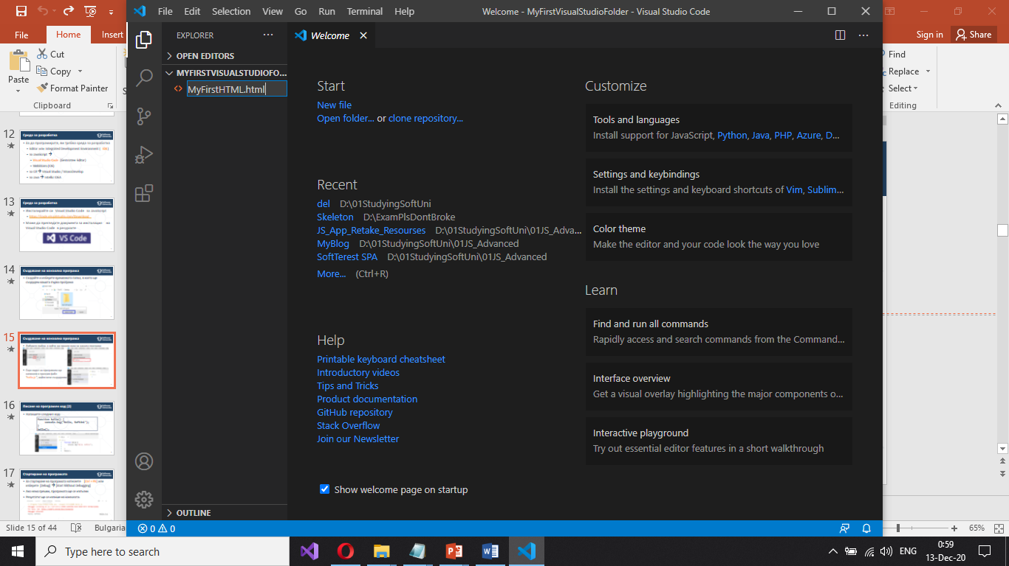

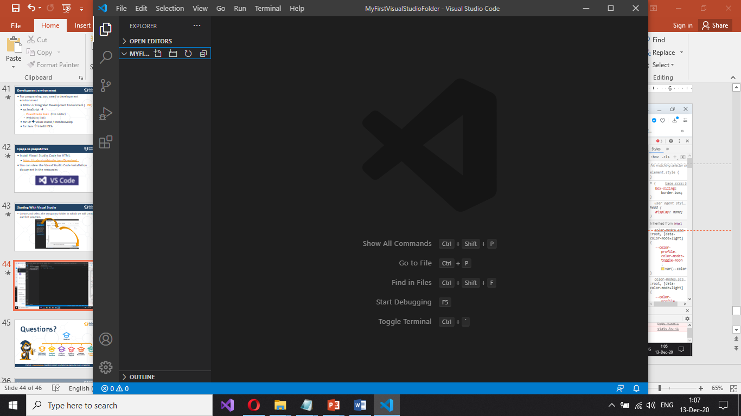

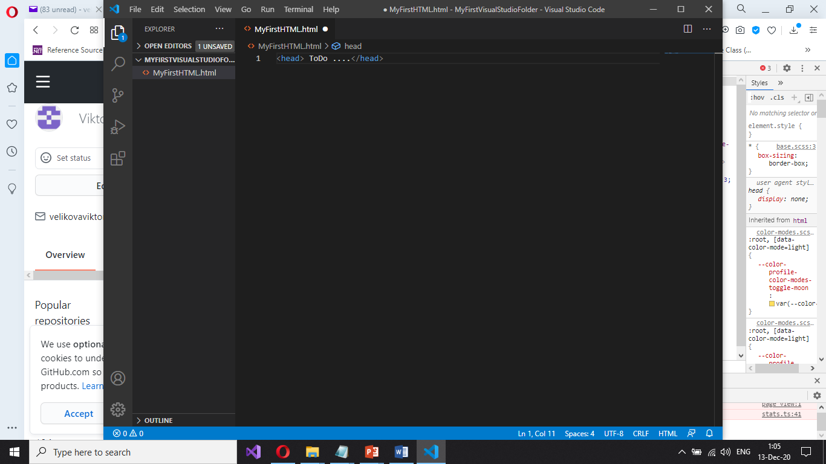

1. Install the **extension** “Live Server”:

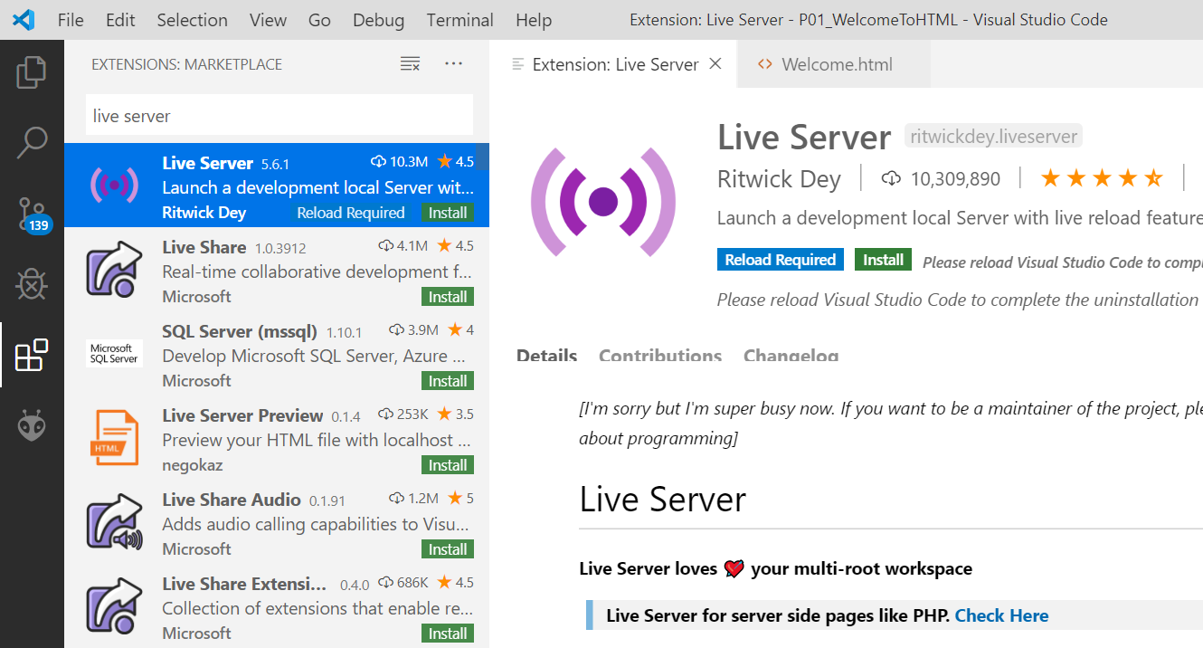

1. Тo see the result of the written code in a browser, **right-click** on the project and select [**Open with Live Server**].

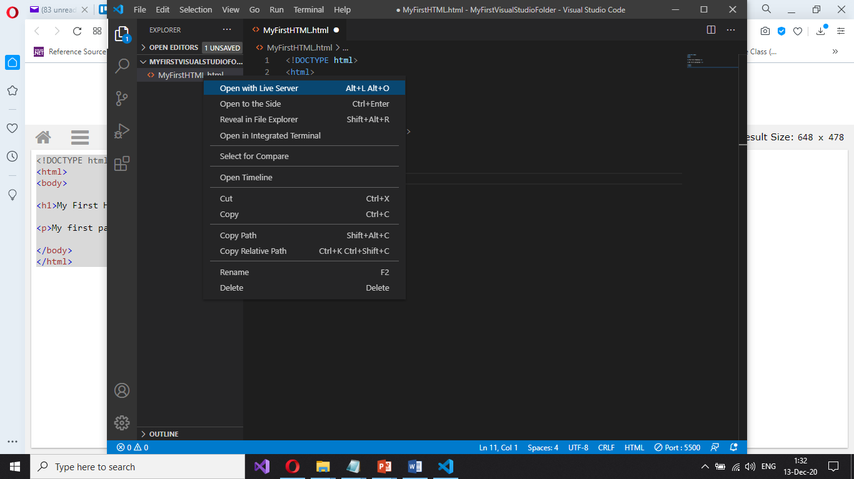

You will see the output from your HTML code in the Web browser:

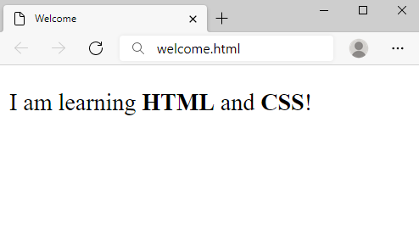

## How to Send Solutions in Judge?

Make a **zip** archive of your solution by **right-click on the HTML file > [Send to] > [Compressed (zipped) file].**

**Drag the zipped** file to judge over the button [**Select files**] and drop it. After that hit [**Submit**] button.

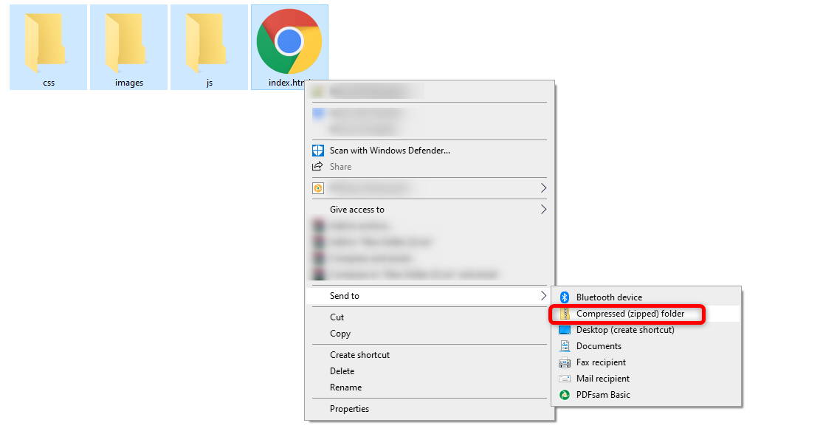

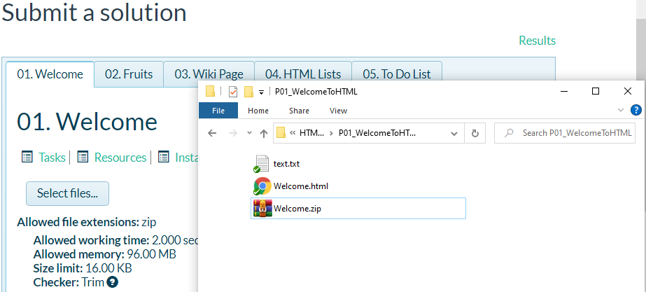

## Welcome to HTML

Create a Web Page like the following:

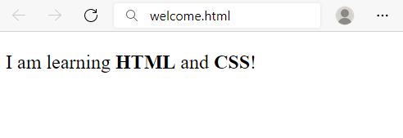

Create file named welcome.html. Use the texts from the filesite-texts.txt.

### Requirements

* Title: Welcome
* <strong> tag for **bold** text
* <p>tag for paragraph

## Fruits

Create a Web Page like the following:

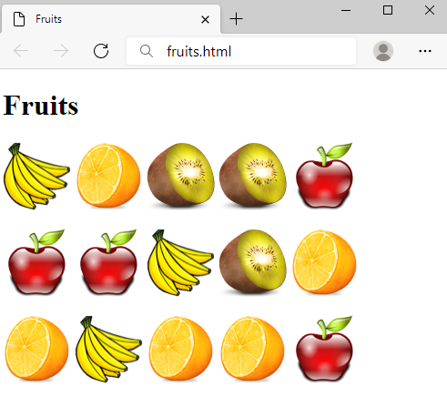

Create a file fruits.html.

### Requirements

* Titile: Fruits
* <h1> tag for **heading**
* <img> tag for **images**

### Hints

* Use 3 **paragraphs**, each holding 5 images

## Wiki Page

Create a Web Page like the following:

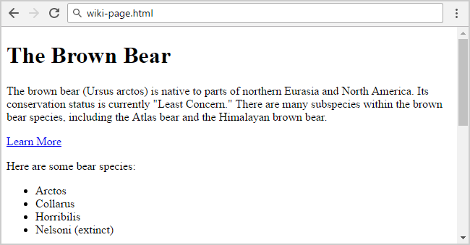

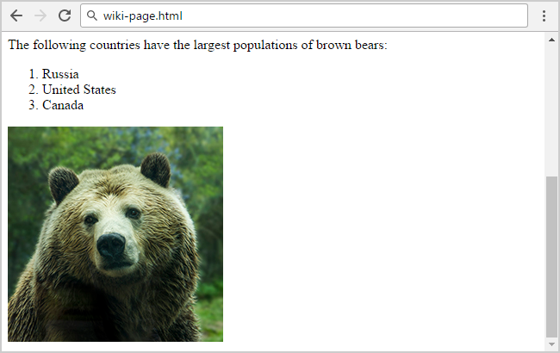

Create file: wiki-page.html. Use the texts from the filesite-texts.txt.

### Requirements

* Title: **The Brown Bear**
  + <h1> for heading
* Hyperlink: <https://en.wikipedia.org/wiki/Brown_bear>
* Text: **use paragraph**
* List: **use ordered list** and **unordered list**
* Image: bear.jpg

## To Do List

Create a Web Page like the following:

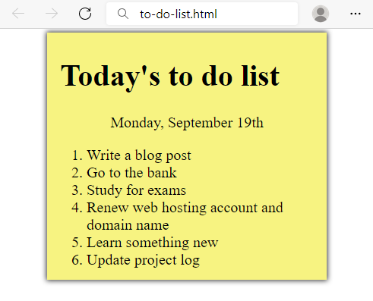

Create two files: to-do-list.html and to-do-list.css. Use the texts from the filesite-texts.txt. Use the texts from the filesite-texts.txt. Set the html title to be the same as the task name.

### Requirements

* **<main>** with **class="my-list"** as container
  + Background Color: **#f7f381;**
  + Padding: 8px 24px;
  + Width: 500px;
  + Text size: 30px;
  + Border: 1px solid #f7f381;
  + box-shadow: 0 0 10px 2px #333333;
* <ol>
  + Margin: 12px;
* <p>
  + Center the text

### Hints

* Center the **container**
* Heading: use <h1>
* Date: use <p> + center it
* List: use <ol>

## HTML Lists

Create a Web Page like the following:

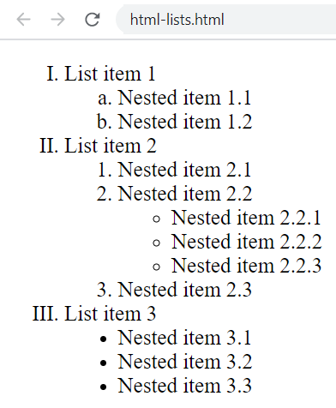

Create file: html-lists.html. Use the texts from the filesite-texts.txt. Use the texts from the filesite-texts.txt. Set the html title to be the same as the task name.

### Hints

Use: <ol>, <ul> and <li>. You need to use **nested** lists.

## Definition Lists

Create a Web Page like the following:

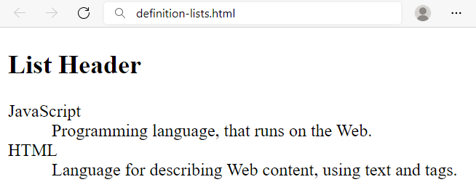

Create a file named definition-lists.html. Use the texts from the filesite-texts.txt. Set the html title to be the same as the task name.

### Requirements

* <h2> tag for heading
* <dl> + <dt> + <dd> tags for definition list

## Reversed List

Create a Web Page like the following:

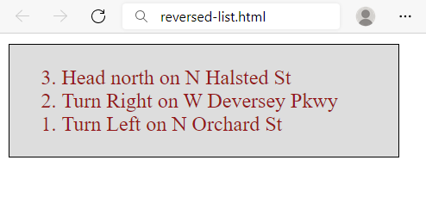

Create two files: reversed-list.htmlandreversed-list.css. Use the texts from the filesite-texts.txt. Set the html title to be the same as the task name.

### Requirements

* <main>with **id=wrapper** as a **container**
  + Background color: #dddddd;
  + Text color: #95191a;
  + Width container: 300px;
  + Border: 1px solid #000000;

### Hints

Use:

* <ol> with **reversed** attribute
  + <ol reversed="reversed">
* Submit **only** reversed-list.html+reversed-list.cssin **ZIP archive** file

## The Modern JavaScript

Create a Web Page like the following using the texts from site-texts.txt.

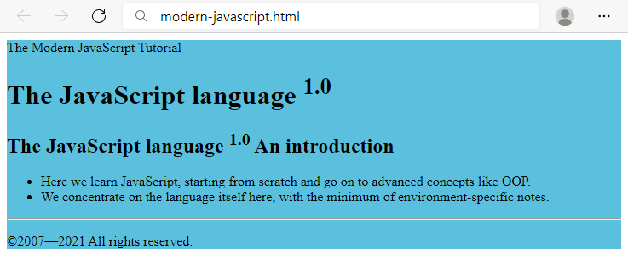

Create two files: modern-javascript.html and modern-javascript.css. Set the html title to be the same as the task name.

### Requirements

* **<main>** with **id=wrapper** as a **container**
  + Background color: **#5bc0de;**

### Hints

Use:

* <h1> and <h2>tags for headings
* <sup>tag for **superscript text**
* <p> tag for paragraphs and **<span>**
* <ul>tag for list items
* <hr />for horizontal line
* <footer>tag for copyright part + **&copy;** for copy right symbol

## Book Story

Create a Web Page like the following using the texts from site-texts.txt. Set the html title to be the same as the task name.

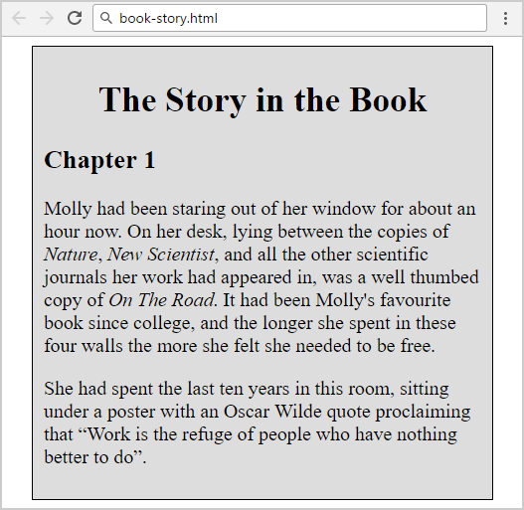

Create two files: book-story.htmlandbook-story.css. Set the html title to be the same as the task name. Set the html title to be the same as the task name.

### Requirements

* **<main>** for the main container
  + Width container: **400px;**
  + Background color: **#dddddd;**
  + Border: **1px solid #000000;**
  + Margin Left**: 20px;**
  + Padding**: 10px;**
* **<p>** tag for paragraph + **font-size: 18px;**
* **<em>** tag for italic text

### Hints

Use:

* **<h1>** tagfor heading + **center the text**
* **<q>** tag for quotation text
  + **q::before {  
     content: open-quote;  
    }**
  + **q::after {   
     content: close-quote;  
    }**

## World Cup News

Create a Web Page like the following.

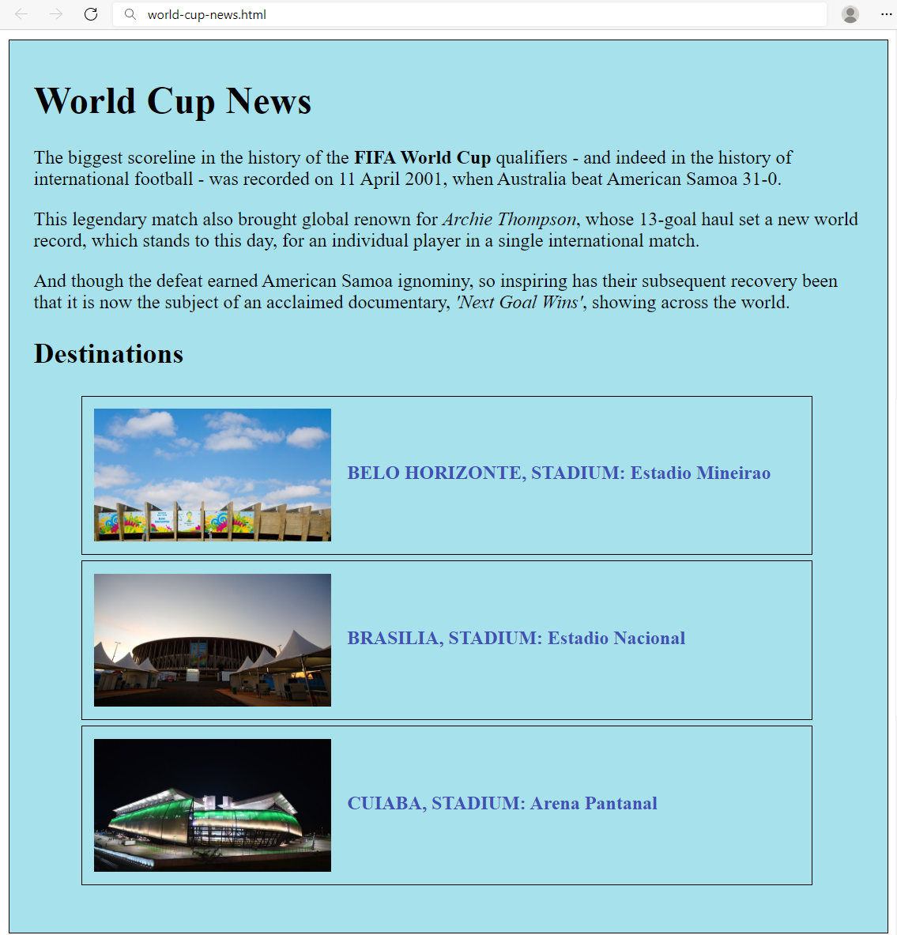

Create two files: world-cup-news.html and world-cup-news.css. Use the texts from the filesite-texts.txt. Set the html title to be the same as the task name.

### Requirements

* **<main>** with **id=** **"wrapper"** as a **container**
  + Width container: 700px;
  + Height container: 730px;
  + Border: 1px solid #000000;
  + Center the **container**
  + Padding**:** 10px 20px;
  + Background Color: #a6e1ec;
* <h1>and<h2>tags for headings
* <p> tag for paragraph
* <strong>tag for **bold** text
* <em>tag for **italic** text
* <img> tag for images
  + Width: 200px;
  + Margin Right: 10px;
  + Vertical Align:middle;
* <span class= "text">for the text next to images
  + Text color: #3f51b5;
* <li>tag
  + Width: 595px;
  + Padding: 10px;
  + Margin Bottom: 5px;
  + Font Size: 14px;
  + Border: 1px solid #000000;